5.2.3 Average Value Worksheet

- Determine the average value of the function on the interval .

We can use geometry to find the area under on the interval .
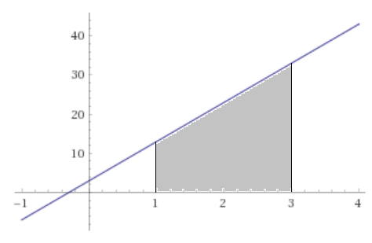

Therefore we have.

- Determine the average value of the function on the interval .

We can use geometry to find the area under on the interval .
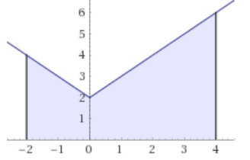

Therefore we have.

- Find all numbers c that satisfy the MVT for Integrals for the function on the interval .

Since is continuous on , the MVT for integrals states that there is a c in such that:

So we have .

- Find all numbers c that satisfy the MVT for Integrals for the function on the interval .

Since is continuous on , the MVT for integrals states that there is a c in such that:

So we have .

Since both values are in the interval they are both acceptable values of c.

- Suppose the function is continuous on the interval and . Show that the function assumes the value of 4 at least once on the given interval.

By the Mean Value Theorem we know that there must exist a number c in such that

- Suppose that a car with whose velocity (in feet per second) after t seconds is given by . Show that the car must have been moving at a speed of 135 ft/sec at some point during the interval

We can see that since is a polynomial is must be continuous and differentiable on .
Therefore, by the Mean Value Theorem for Integrals we know that there must exist a number c in such that

